## Setup Extension

A Lineblocs extension allows you to route calls to a softphone or hard phone.

Extensions can be created and managed using the Lineblocs dashboard. You can provide new extensions on-demand, as well as update an Extension's default Caller ID and other settings.

## Create Extension

1. In the Lineblocs dashboard click "Create" -> "New Extension"
2. Enter a username for your extension
3. Enter a Caller ID
4. Enter a Secret
5. Click "Save"

## Connecting

To get the information to connect to your extension using a softphone or supported hard phone, please go to [Extensions](https://app.lineblocs.com/#/extensions) page, then click the info bubble IMG_256 next to the extension you want to connect to.

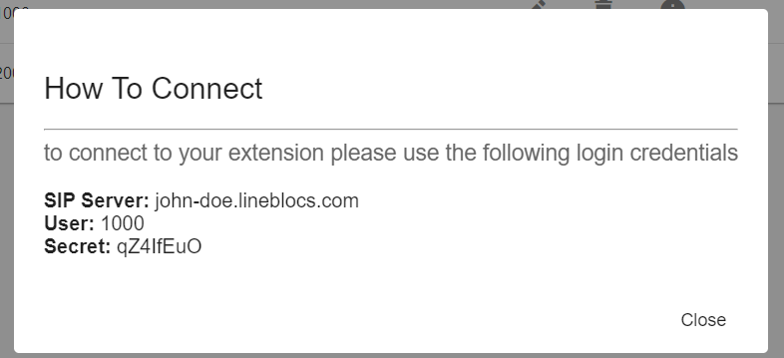

## Managing Extensions

You can edit or delete your extension at any time.

To edit an extension:

Click the "Edit" button next to the extension you want to edit.

To delete an extension:

Please click the "Delete" button next to the Extension you want to remove.

## Next Steps

In this guide, we went over how to create and connect to extensions. For related posts, be sure to view:

[Extension security best practice](https://lineblocs.com/resources/other-topics/extension-security)

[Avoiding call spam](https://lineblocs.com/resources/other-topics/report-spam)